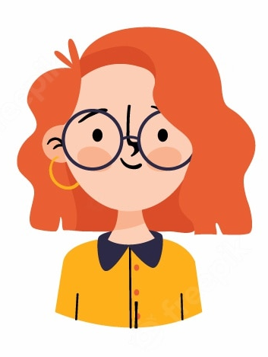 | Lisa Jones | Graphic Designer  London, UK  0777700000  lisa@jones.com
Professional Summary
I am a creative, artistic, and ambitious Graphics Designer with a talent for thinking outside the box and coming up with innovative ideas and designs. I graduated with a 1st Class honours degree in Graphic Design from UCL and subsequently have worked in the design industry for the past 2 years. I pride myself in providing excellent service to all stakeholders and seeing the positive impact I make in people's lives and businesses.

Skills
- Graphic Design  - Adobe  - FreeHand  - Photoshop | - Illustrator  - Dreamweaver  - Flash  - HTML

Work History
Graphic Designer |  | Sep 2019 – Current
Freelance – London
Working as a Freelance Graphic Designer for a variety of clients across London.
Responsibilities included:
- Discussing projects and requirements with clients and account managers.
- Interpreting client requirements and developing appropriate concepts to present to the client.
- Providing clients with quotes and presenting design concepts to the client.
- Producing designs by means of various types of media, including photography and graphics programs.
- Staying up-to-date with the specialist graphic design programs and technology used in graphic design (e.g. Quark Xpress, FreeHand, Illustrator, Photoshop, 3D Studio, Acrobat, Director, Dreamweaver, Flash).

Education
1st Class Honors Degree in Graphic Design  University College London | Graduated 2019

